Employee Performance Review for an Undisclosed Client, ASP.NET 4.0, C# 3.0 HTML4 and CSS2 Website, which was stored on IIS 6. This website was managed with me being the Lead within the project.

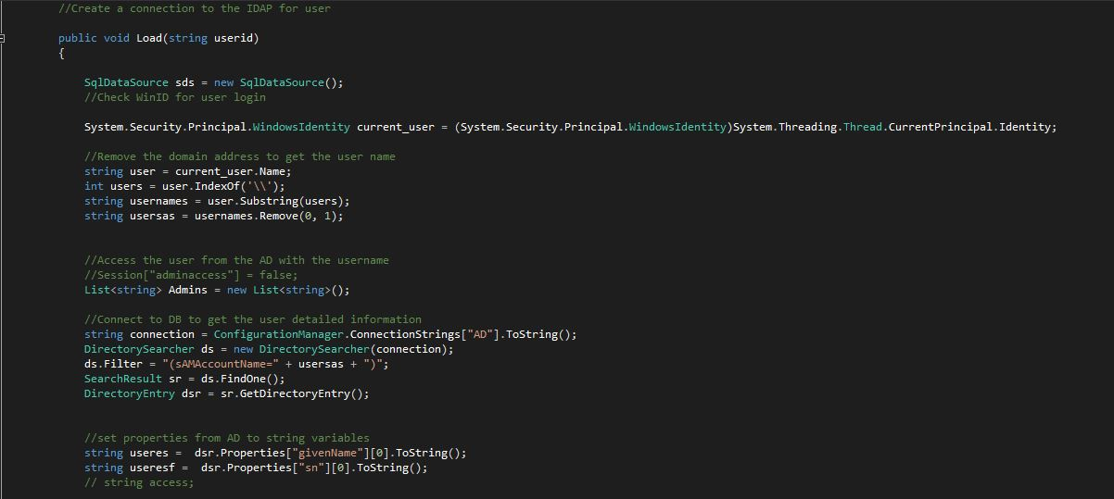

This part of the code I was able to get the User ID from the Active Directory (AD) from the Windows Domain, utilizing this I was able to authenticate the user to the database and base on their role within the AD. I was able to redirect the page to the appropriate login for Performance Reviews within the system.

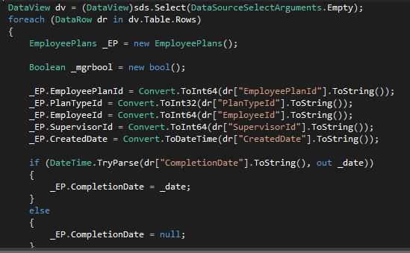

This part of the code I was able to create a DataView from the Data gathered from Active Directory and verify the user information for their performance review against the database within Human Resources. During this task one was able to create a new database with verify employees and store this information for future use within the performance review.

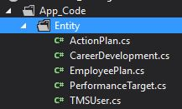

This is the design of the Entity Framework for the Website being created.